*STUDENT SATISFACTION SURVEY REPORT - 2021-22
Feedback is an essential part of learning effectively and enhancing student's learning experiences. Students have a unique perspective of how their teachers educate. Obtaining student feedback allows the students to actively become more engaged and involved in the classroom. Student feedback gives teachers the opportunity to make any adjustments to their teaching as quickly as possible. A student satisfaction survey is conducted annually by the institution. A structured questionnaire, related to curriculum, infrastructure, governance, etc. is filled by the students. A detailed analysis of the survey is done and report is formed so that necessary improvements can be introduced. The report of the SSS- 2021-22 is as follows:
S. No | What degree program are you pursuing now? | Percentage of responses
 | BA | 28.9
 | BCom | 22
 | BCA | 13.7
 | BBA | 12.2
 | BVoc | 4.8
 | MA | 6.0
 | MSc | 3.5
 | MCom | 8.9

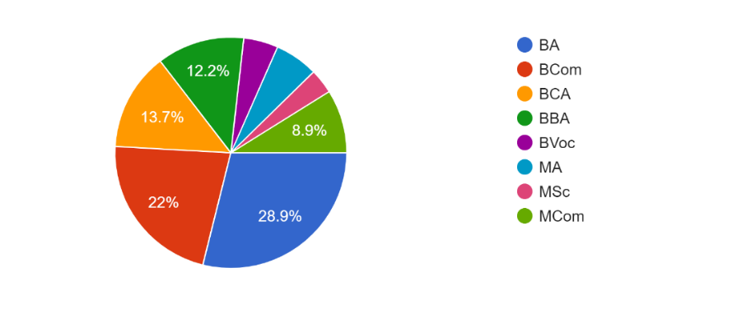

S. No | Year of Study * | Percentage of responses
 | I Year | 43.2
 | II Year | 46.3
 | III Year/ Final | 10.5

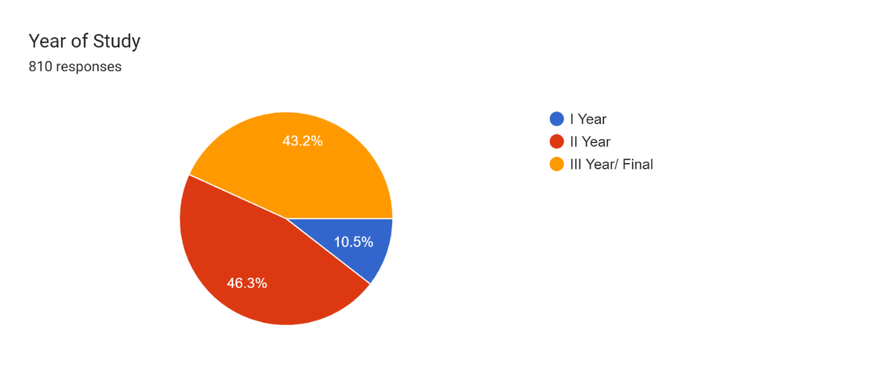

S. No | Syllabus covered | Percentage of responses
 | 70 to 100% | 50.2
 | 35 to 70% | 41.2
 | Below 35% | 8.6

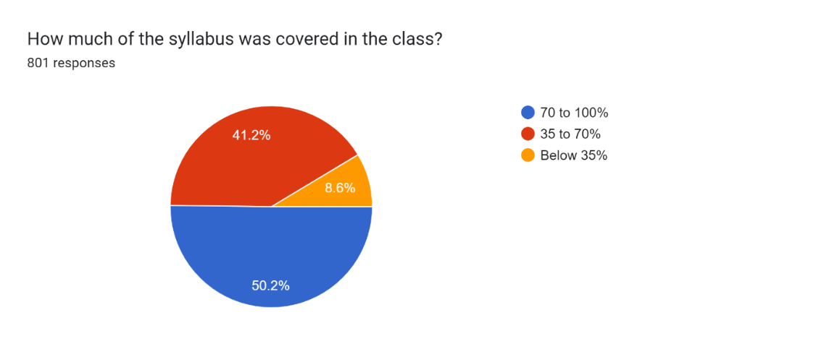

S. No | Did the teachers discuss the topics in detail? | Percentage of responses
 | Always | 76.9
 | Sometimes | 22
 | Never | 1.1

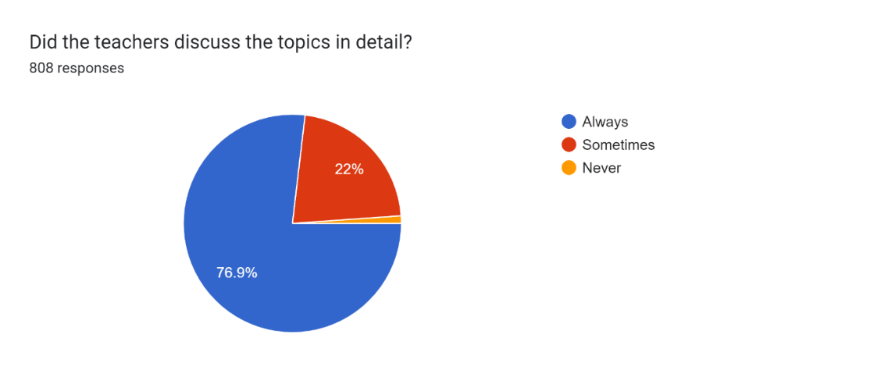

S. No | Are the teachers able to communicate clearly? | Percentage of responses
 | All the teachers | 67.6
 | Some of the teachers | 32
 | none of the teachers | 0.4

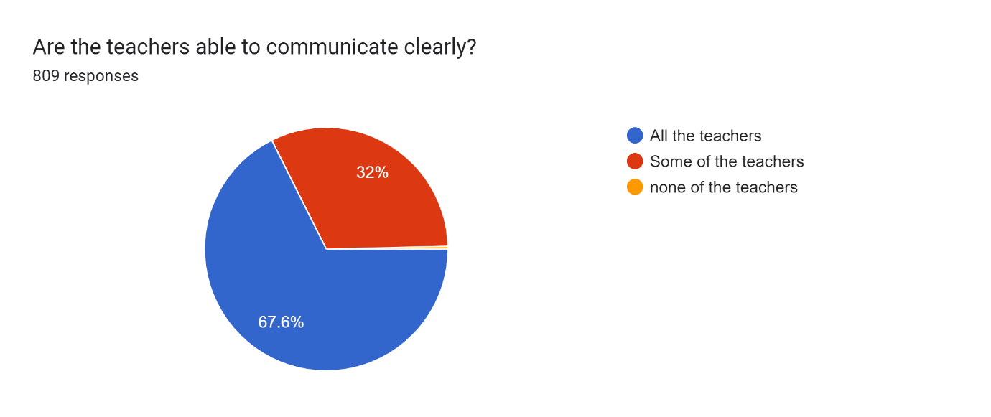

S. No | Are the teachers punctual to the class? | Percentage of responses
 | Always | 69.8
 | Most of the times | 28.8
 | Never | 1.4

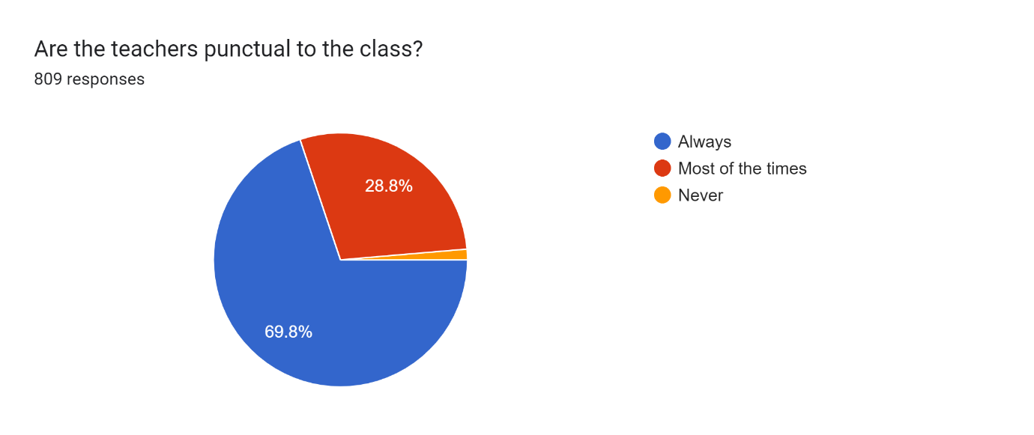

S. No | Do the teachers come fully prepared for the class? | Percentage of responses
 | Always | 83.3
 | Sometimes | 15.5
 | Never | 1.2

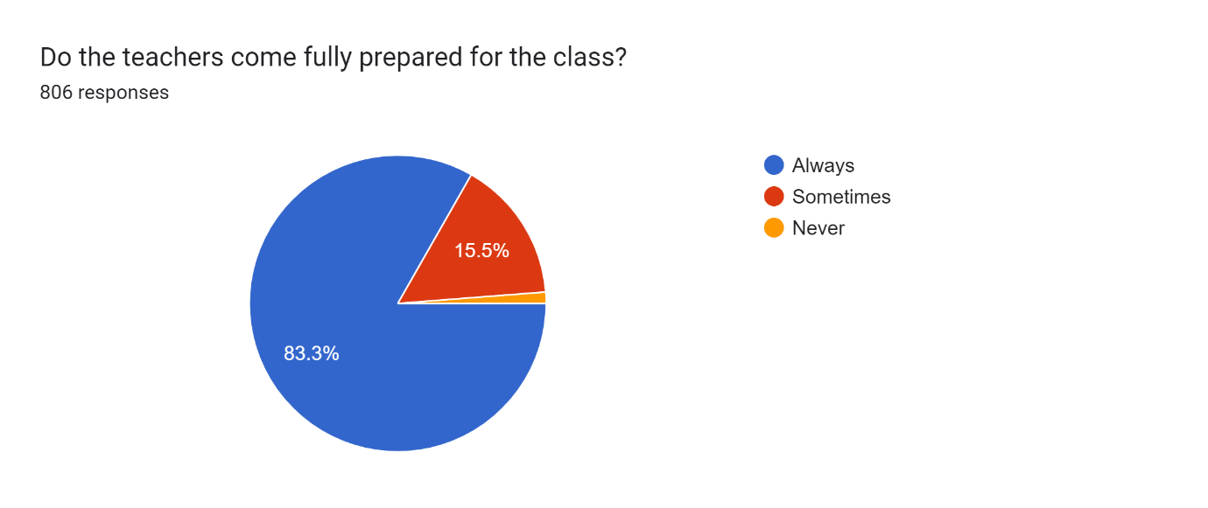
S. No | Do the teachers provide guidance & counselling in academic and non- academic matters in/ outside the class? | Percentage of responses
 | Always | 63.2
 | Sometimes | 29.6
 | Never | 7.3

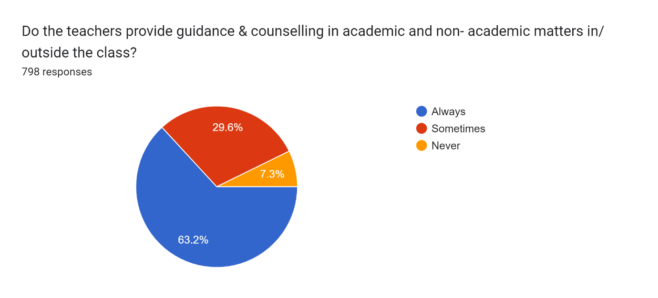

S. No | Do the teachers encourage participation and discussion in the class? | Percentage of responses
 | Always | 76.9
 | Sometimes | 19.7
 | Never | 3.4

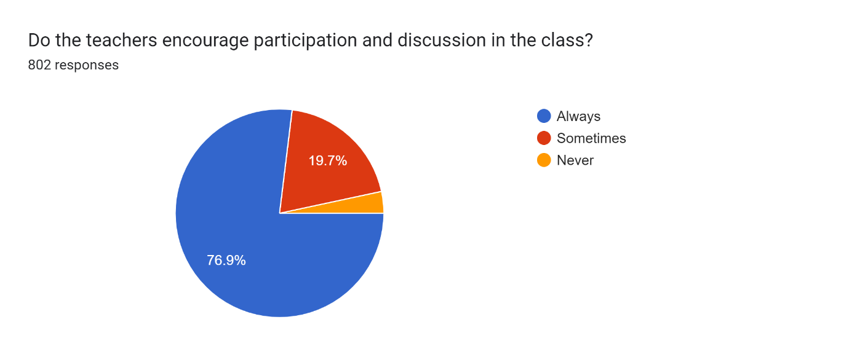

S. No | Do the teachers use modern teaching aids/ handouts, references, PPT, web resources etc? | Percentage of responses
 | Always | 42.6
 | Sometimes | 39.6
 | Never | 17.9

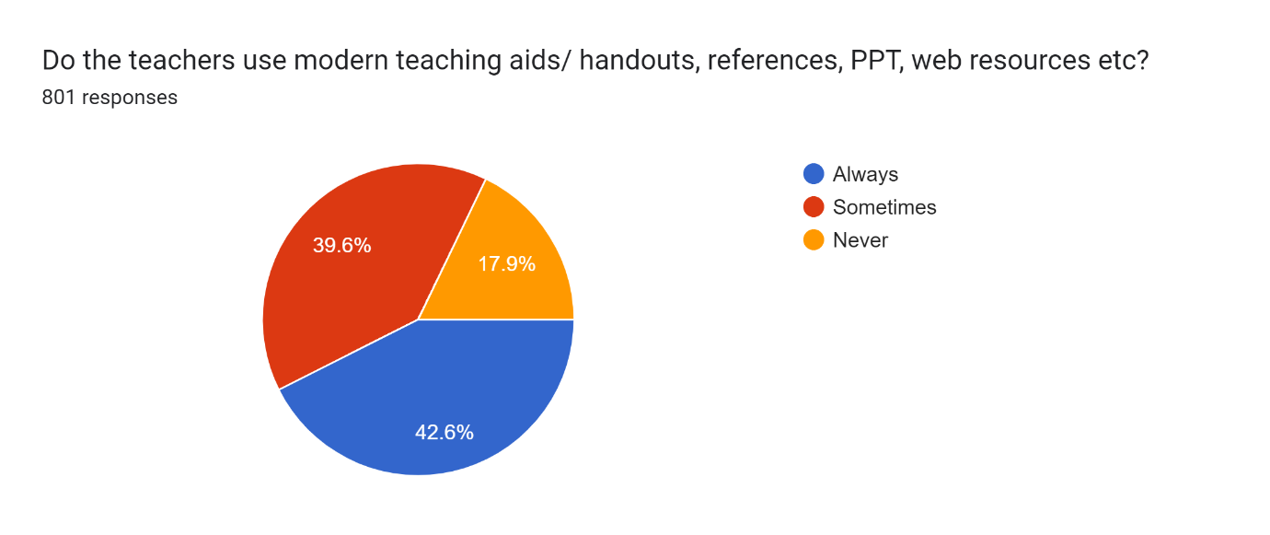

S. No | Do the teachers pay attention to academically weak students? | Percentage of responses
 | Always | 61.7
 | Sometimes | 27.9
 | Never | 10.3

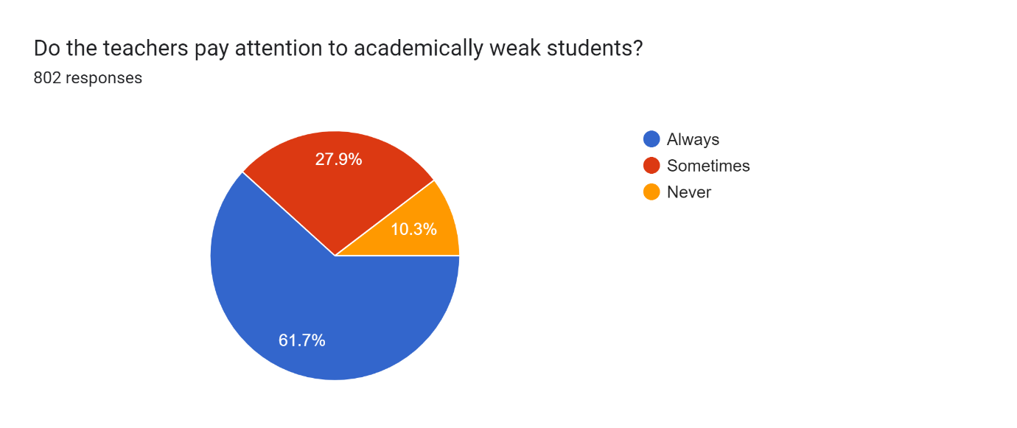

S. No | Are the teachers fair and unbiased in the evaluation process? | Percentage of responses
 | Always | 61.8
 | Sometimes | 28.8
 | Never | 9.4

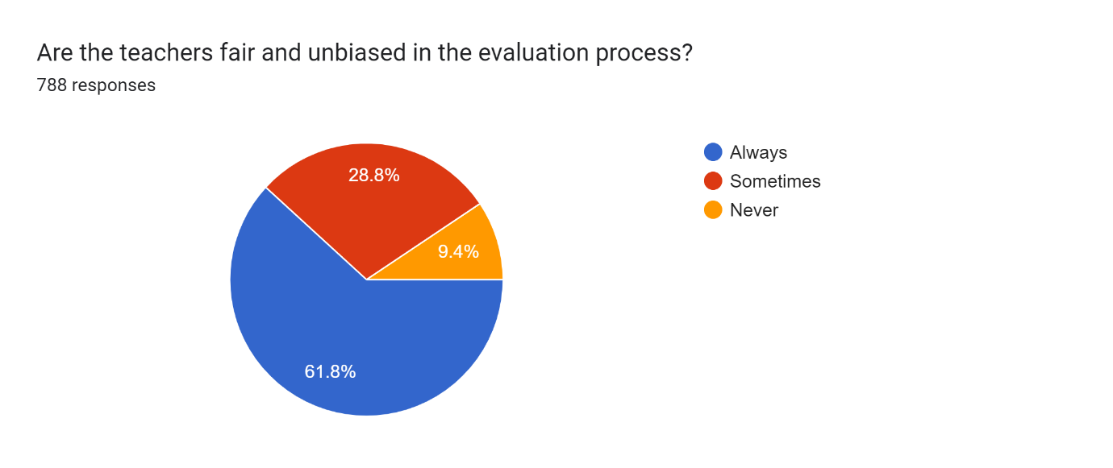

S. No | How is cataloguing and arrangement of books in library? | Percentage of responses
 | Excellent | 29.6
 | Good | 60.6
 | Poor | 9.8

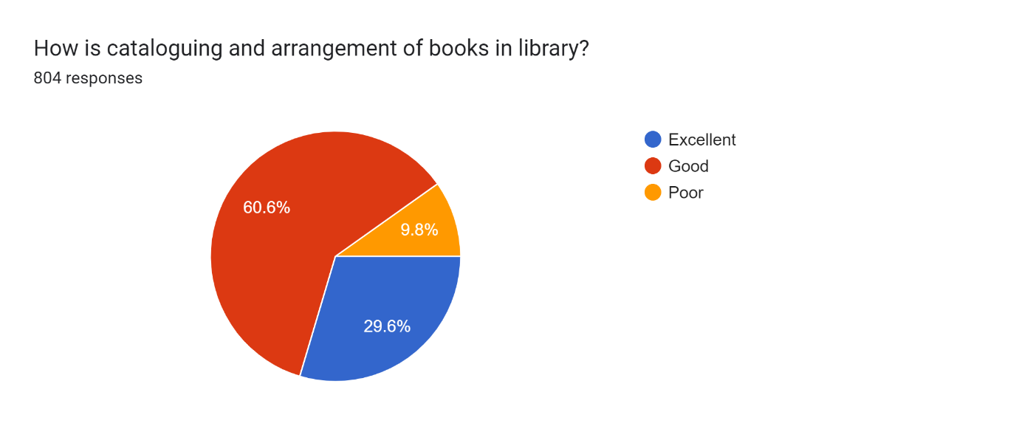

S. No | Are you satisfied with the reading space in the library? | Percentage of responses
 | Fully Satisfied | 60.9
 | Not Satisfied | 12
 | Somewhat Satisfied | 27.1

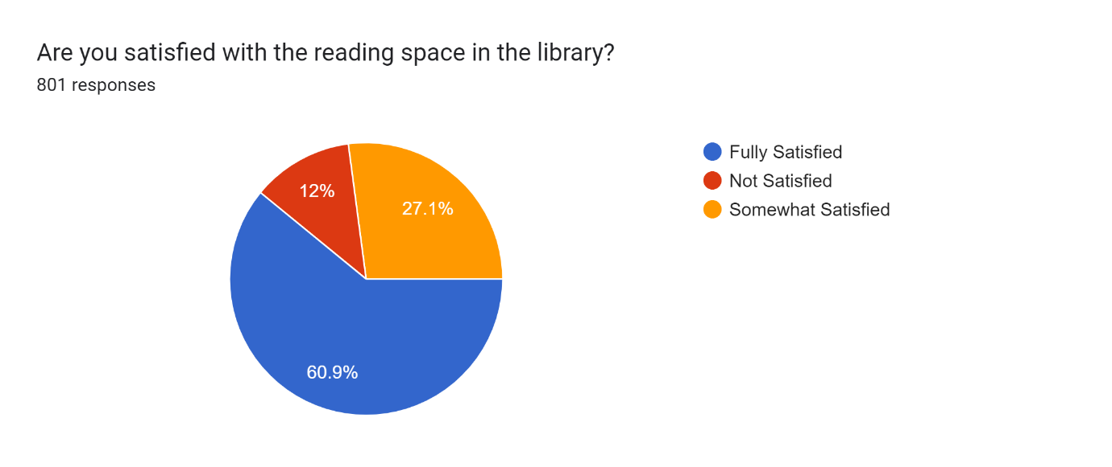

S. No | How do you find the attitude and support of library staff? | Percentage of responses
 | Very Supportive | 73.6
 | Indifferent | 19.3
 | Not Supportive at all | 7.1

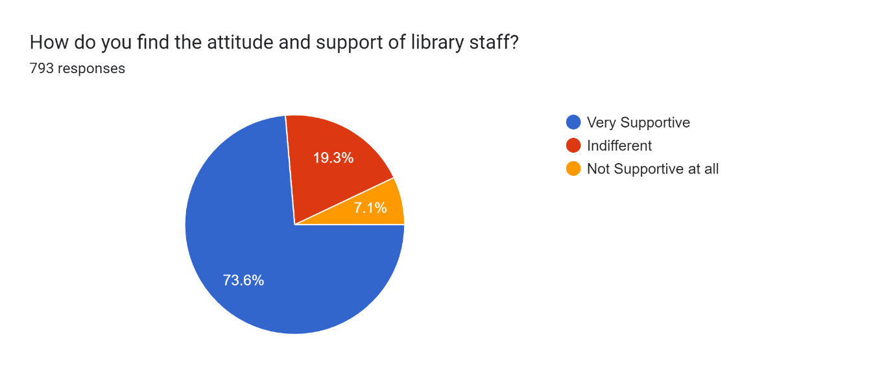

S. No | Is there availability of clean drinking water in the institution? | Percentage of responses
 | Yes | 77.7
 | No | 22.3

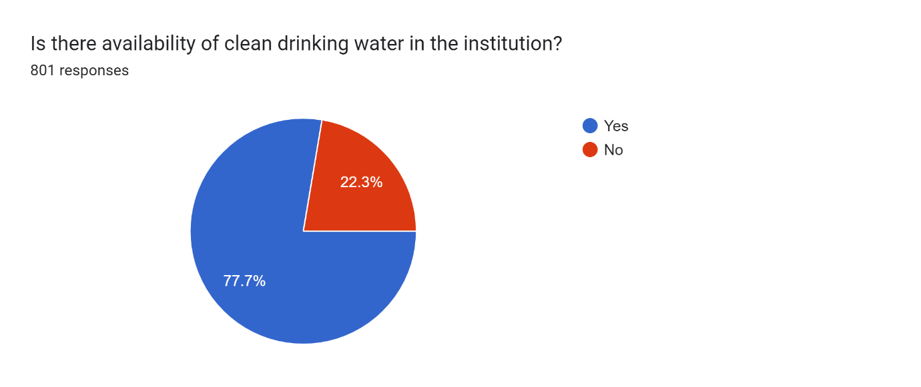

S. No | Are there sufficient number of toilets available in the college? | Percentage of responses
 | Yes | 82.5
 | No | 17.5

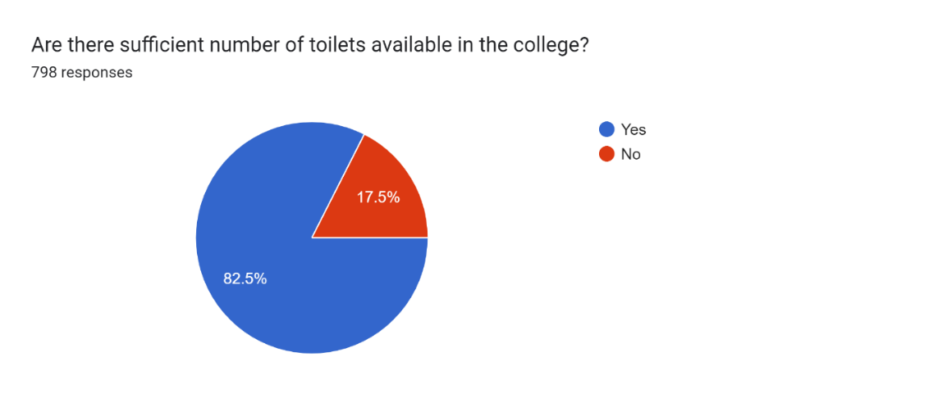

S. No | Are the toilets in the college hygienic and clean? | Percentage of responses
 | Most of the times | 41.3
 | Sometimes | 39
 | Never | 19.7

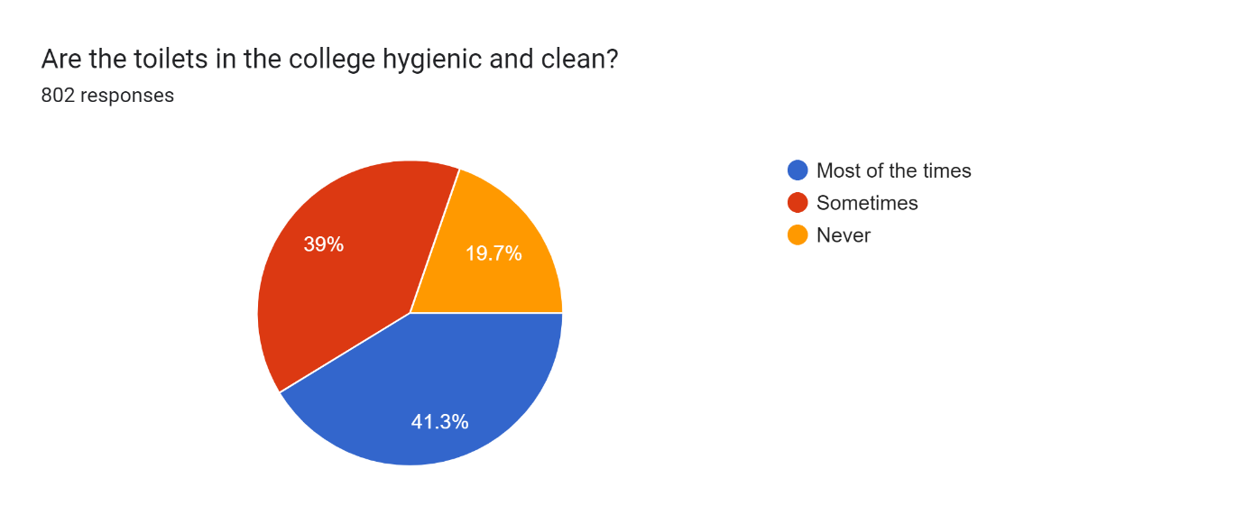

S. No | Is a well-equipped medical room available in the college? | Percentage of responses
 | Yes | 53.9
 | No | 12.3
 | Don't Know | 33.8

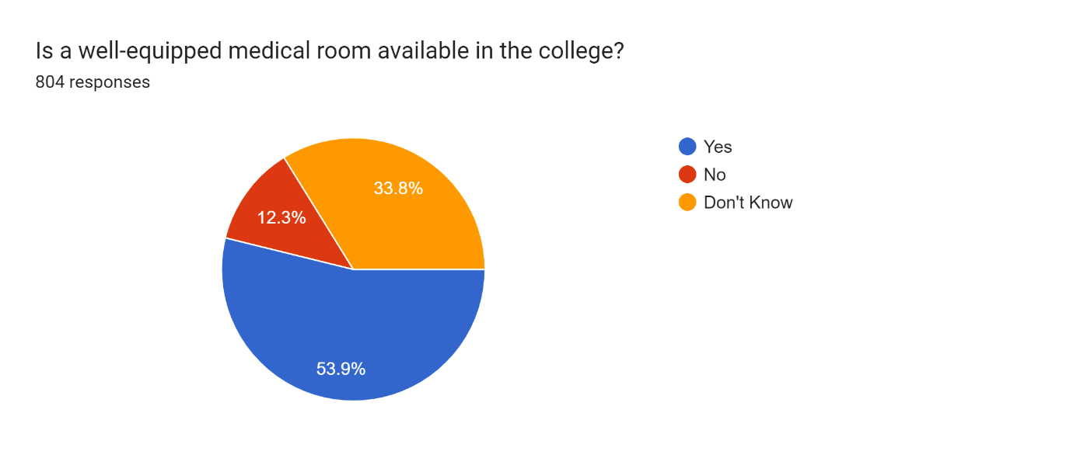

S. No | Are there any first-aid facilities in case of emergency? | Percentage of responses
 | Yes | 53.1
 | No | 11.1
 | Don't Know | 35.8

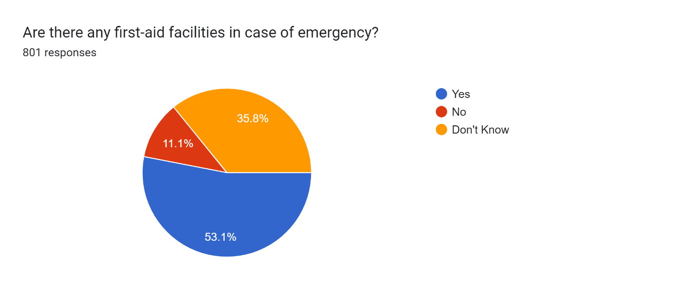

S. No | Are the sports equipment and playgrounds satisfactory? | Percentage of responses
 | Agree | 57.9
 | Disagree | 13
 | Don't Know | 29.1

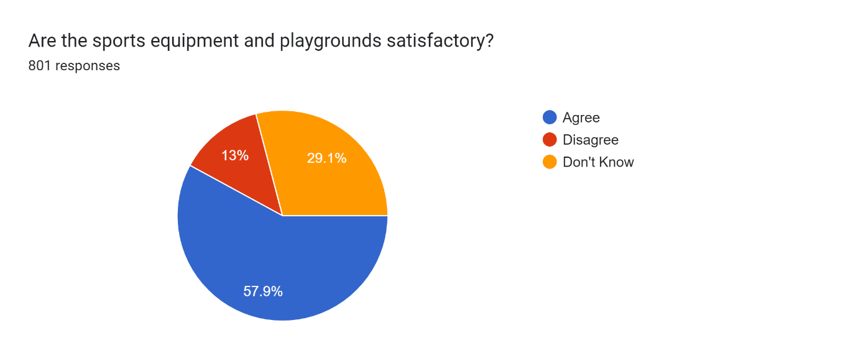

S. No | Does the sports department motivate students to take part in games? | Percentage of responses
 | Yes | 56.9
 | No | 11.3
 | Maybe | 31.8

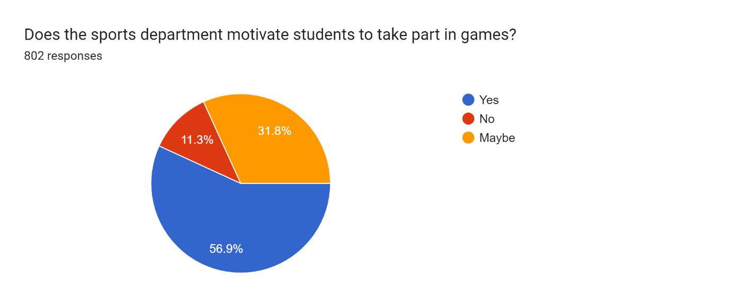

S. No | Does the institution provide satisfactory redressal of student's grievances? | Percentage of responses
 | Yes | 58.8
 | No | 10
 | Don't Know | 31.1

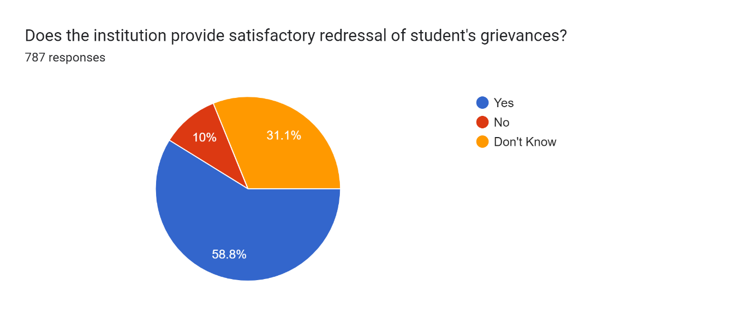

S. No | Are you made aware of the availability of various scholarship schemes? | Percentage of responses
 | Yes | 72.6
 | No | 27.4

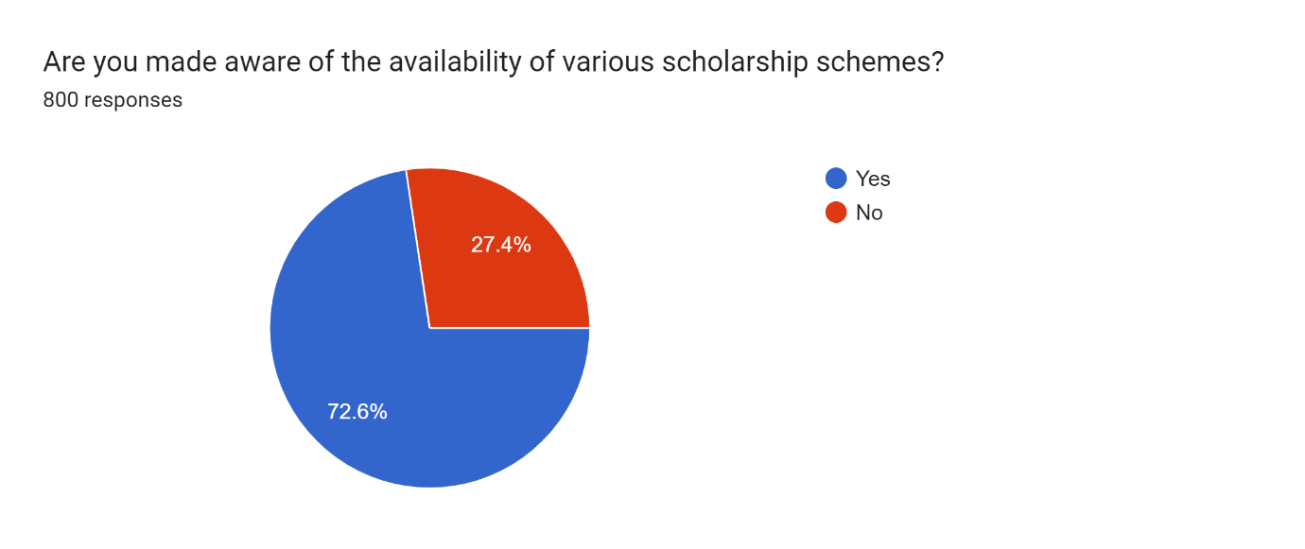

S. No | How do you find the functioning of student’s council? | Percentage of responses
 | Satisfactory | 59.1
 | Unsatisfactory | 9.8
 | Neutral | 31.2

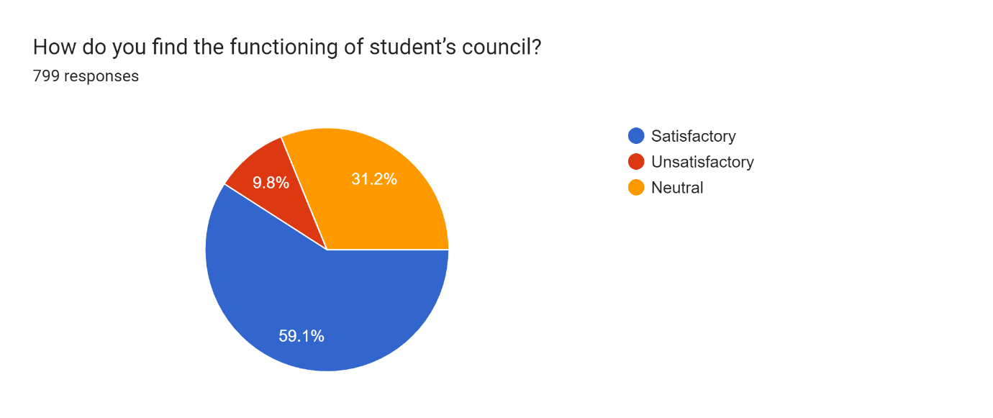

S. No | Is there availability of skill development facilities/ summer internships/ placement in the institution? | Percentage of responses
 | Yes | 56.3
 | No | 13.9
 | Don't Know | 29.8

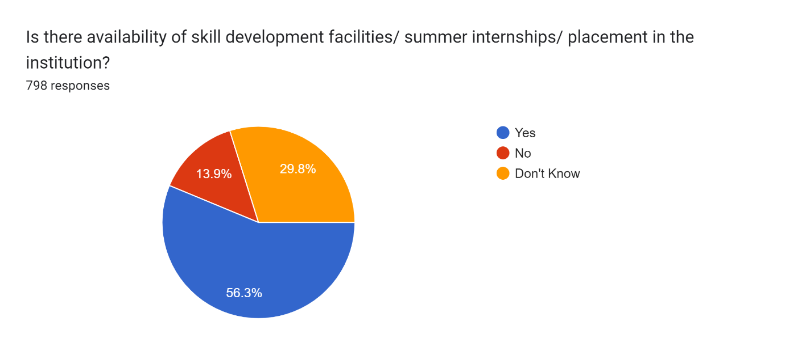

S. No | Is the administrative staff polite, helpful and efficient in its functioning? | Percentage of responses
 | Agree | 69.1
 | Disagree | 9.2
 | Neutral | 21.7

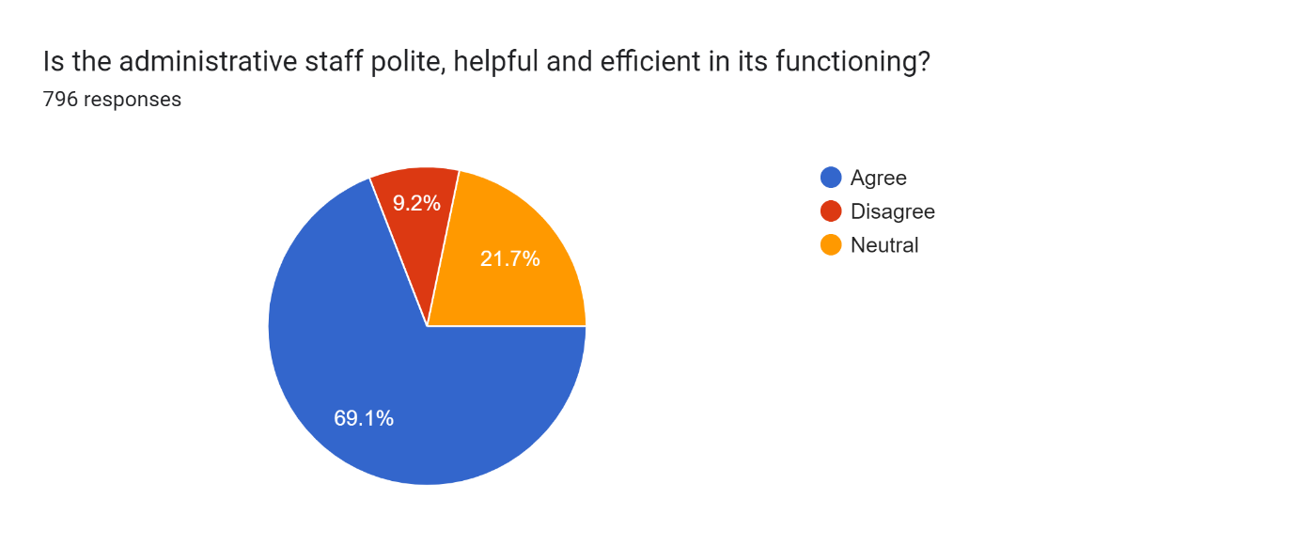

S. No | Do you find Head of the institution and Heads of the Department approachable? | Percentage of responses
 | Yes | 87
 | No | 13

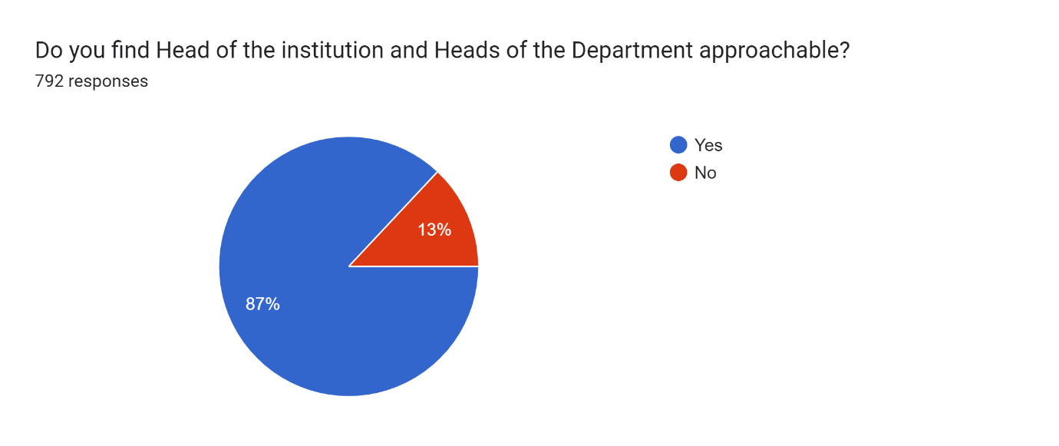

S. No | Are you satisfied with the student’s guidance and counselling cell? | Percentage of responses
 | Yes | 76.2
 | No | 9.5
 | Don't Know | 24.4

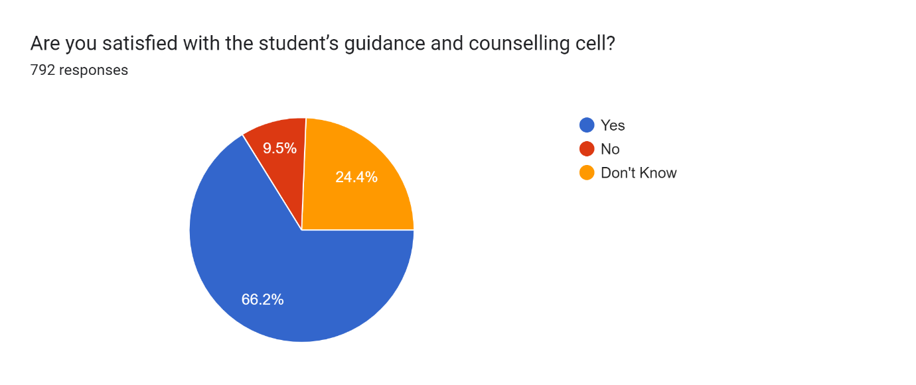

S. No | Does the institution promote student's participation in extracurricular activities? | Percentage of responses
 | Always | 61.9
 | Sometimes | 33.2
 | Never | 4.9

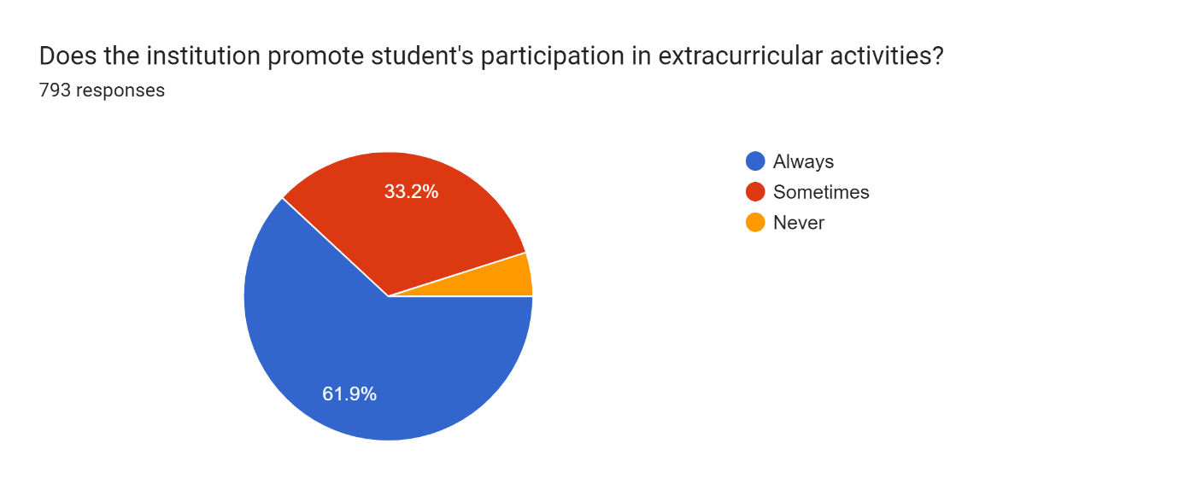

S. No | Does the institution provide Life skill education (education relating to personality development and character building)? | Percentage of responses
 | Yes | 83.3
 | No | 16.7

